Economic Journal Referee Reports
Reviewer 1
Q1.
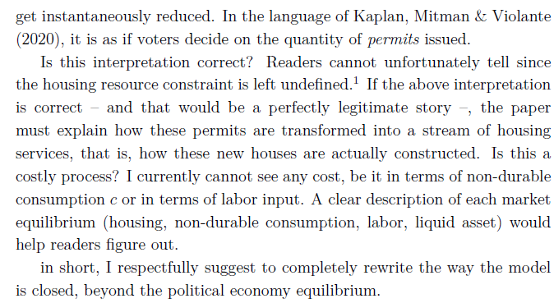
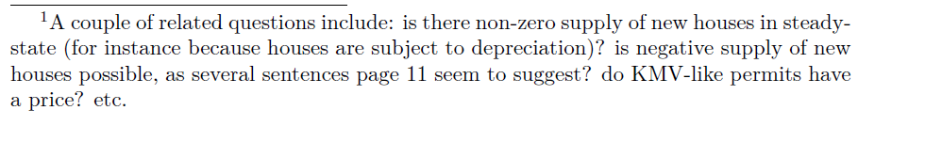
DC: KMV does have permits issued but they are done by the government at a competitive price on page 15. We could re-write this part to say we are following KMV but abstracting from issue
ZG: Yes, I agree. Currently housing is costlessly produced other than permits, but I wonder if there is a way to make a small modification to the model to explain this.

Q2
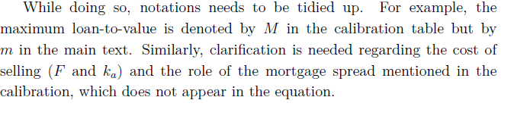
DC:
ZG: Easy fix.

Q3
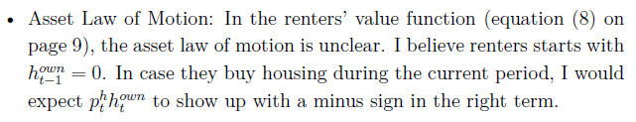
DC: Think R1 is just wrong here as they could have ht as 0 in this equation?
ZG: I will check this, but R1 might be wrong.

Q4
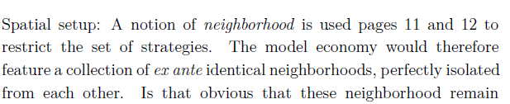
DC: I think the missing thing here is land, I guess the idea here is that permits would expand in to other territories but I am not sure we should add more to this which is clearly just a way to get out of strategic voting.
ZG: The productivity shocks are idiosyncratic at the household level. So they should not effect neighbourhoods.
Q5
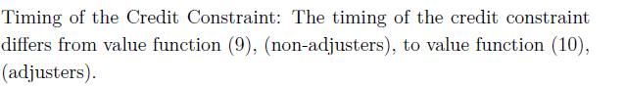
DC: I think 10 should be aT+1?
ZG: Look and fix.

Q6
DC:
ZG: Yes.

Q7
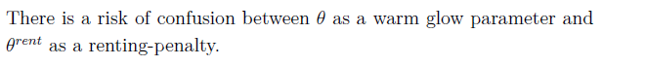
DC:
ZG: Change the warm glow

Q8
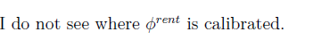
DC:
ZG: Add in.

Q9
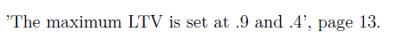
DC:
ZG: Cut the 0.4

Q10
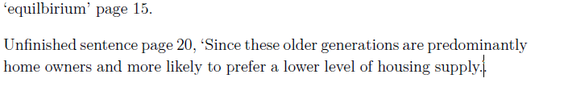
DC: I fixed the typos and merged the last two sentences. Give 5.3 a read just to make sure you ar happy
ZG: OK

Review 2
S1
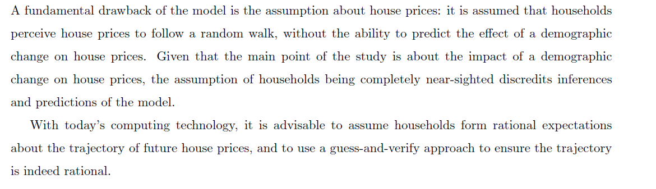
DC: I think we discussed whether we can do this and it was complicated. The question is, do we say why we are not doing this or at least what would happen if this were the case?
ZG: We can probably explain better why the voting makes this hard. The non-linear relationship between demographic shocks and price is one reason why this would be tricky.

S2
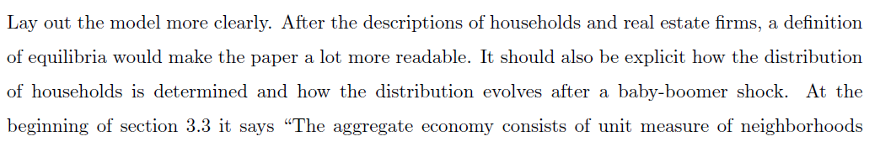
DC: I don’t understand this.
ZG: I can add a definition of equilibrium. I guess add more description of what happens as the shock occurs?

S3
DC: I don’t think this is true
ZG: Correct and will fix, check other instances.

S4
DC: We could make this clearer such as a fixed cost associated with rental services per rental house? Think they are confusing it with the price???
ZG: Yes, agreed.

S5
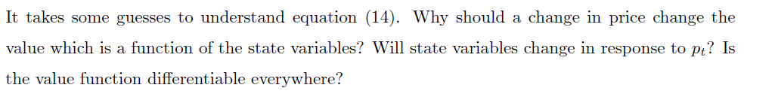
DC: I guess this is one of the issues which we have for not specifically setting out
ZG: We should be more clearer I guess?

S6
DC:
ZG: Can be added.

S7
DC:
ZG: Can be clarified.

S8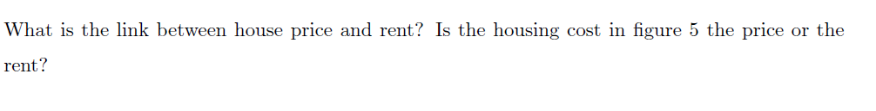
DC:
ZG: Add a footnote explain the link the model.

Reviewer 3

P1
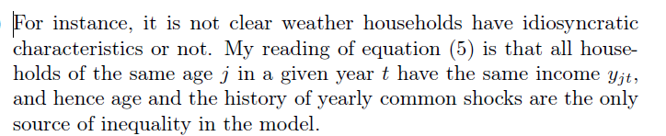
DC: I am not sure how we can rewrite this to make this any clearer?
ZG: Lol, agreed.
P2
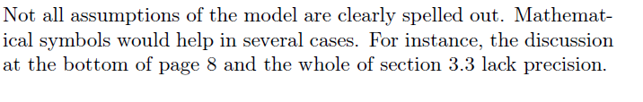
DC: We could appeal to KPV here as what Referee 1 refers to in Q1. I do not know what they mean when they say the bottom of page 8. I do not think modelling all of 3.3 needs mathematical symbols, it seems to be just explaining the model?
ZG: We can try and add a clearer description I guess?

P3
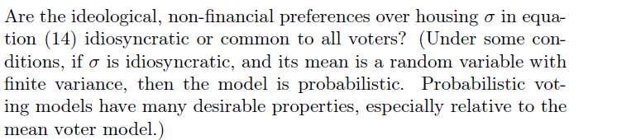
DC: Include a footnote allowing this is a possibility, but would require calibrating a second parameter.
ZG:

P4
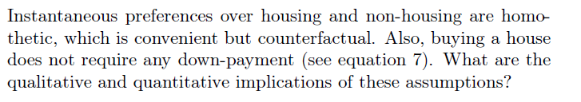
DC:
ZG: Well it does require a down payment. You can only borrow a fixed fraction of the sale price?
P5
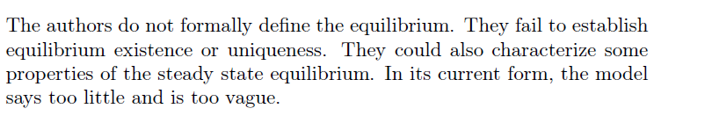
DC:
ZG: Sure. This can be expanded upon.

